Appendix A
First Approximation of a Compliance Reference Model
The compliance reference model will consist of a set of goals and supporting practices. In appraising whether the goals have been met, auditors typically look at the supporting practices to see whether they have been performed or instantiated. Six goals and their supporting practices are outlined below. The complete reference model will define additional levels of detail and alternative supporting practices, while the appraisal methodology will guide auditors in what to look for and how to determine whether or not a goal has been met. Part of the certification includes the requirement that those employees who need to adhere to the process be trained on it. Additionally, as the process is dependent on such employees’ ability to know when the process is triggered (e.g., when certain open source software is used) such employees need to be trained on a consistent set of topical areas that are incorporated into the educational materials, that we propose also form part of the certification criteria.

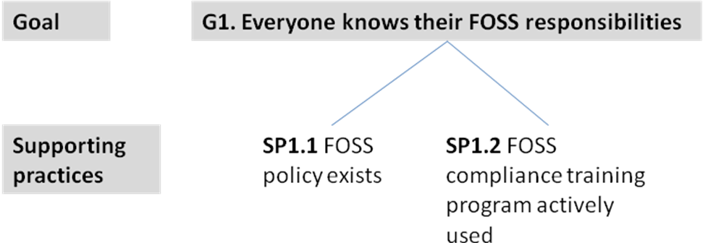

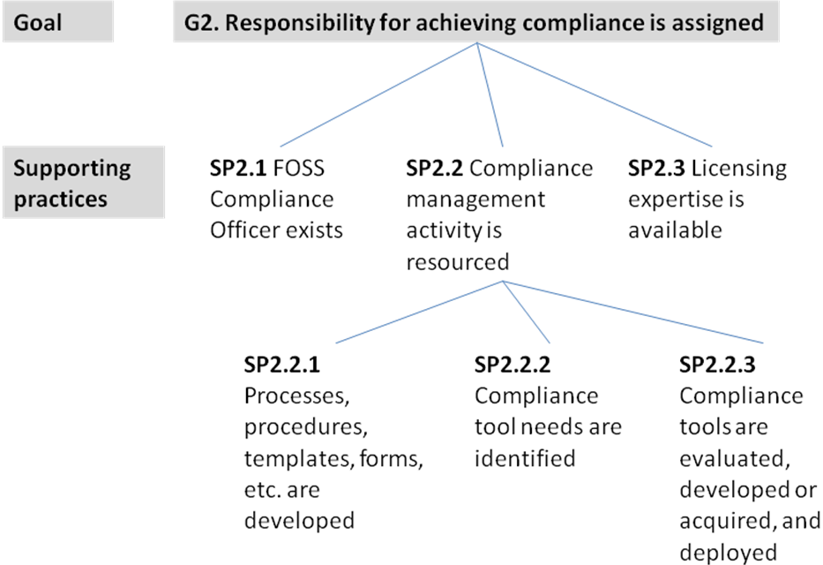

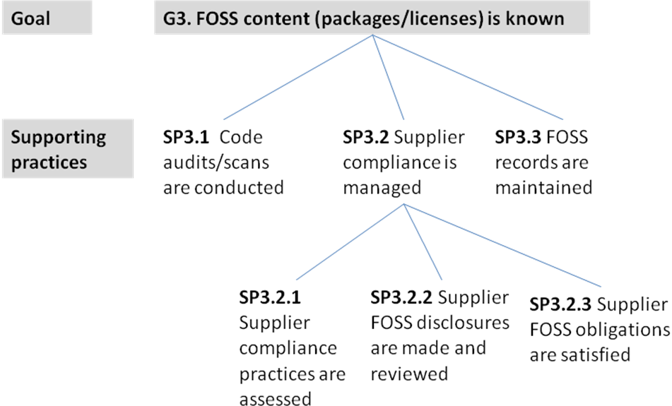

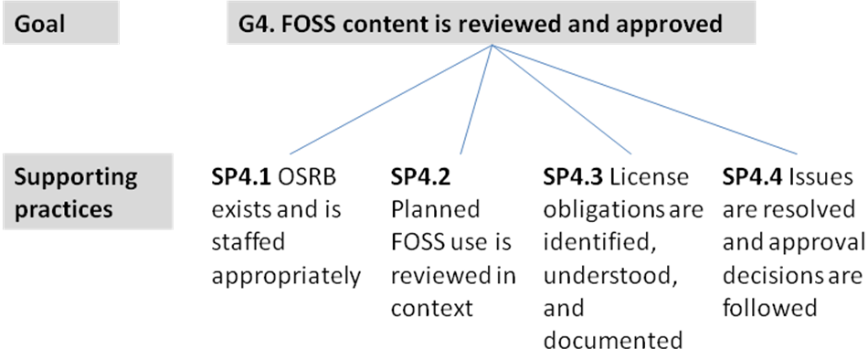

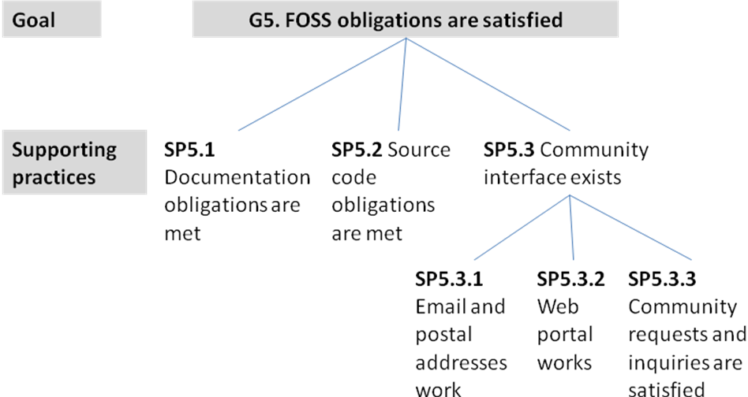

Proposing we remove G6



